Exp17:-
Title of the program:-
Frame a class & store your name & roll no in two variables write a method to print your name & roll no.
Program instruction:-
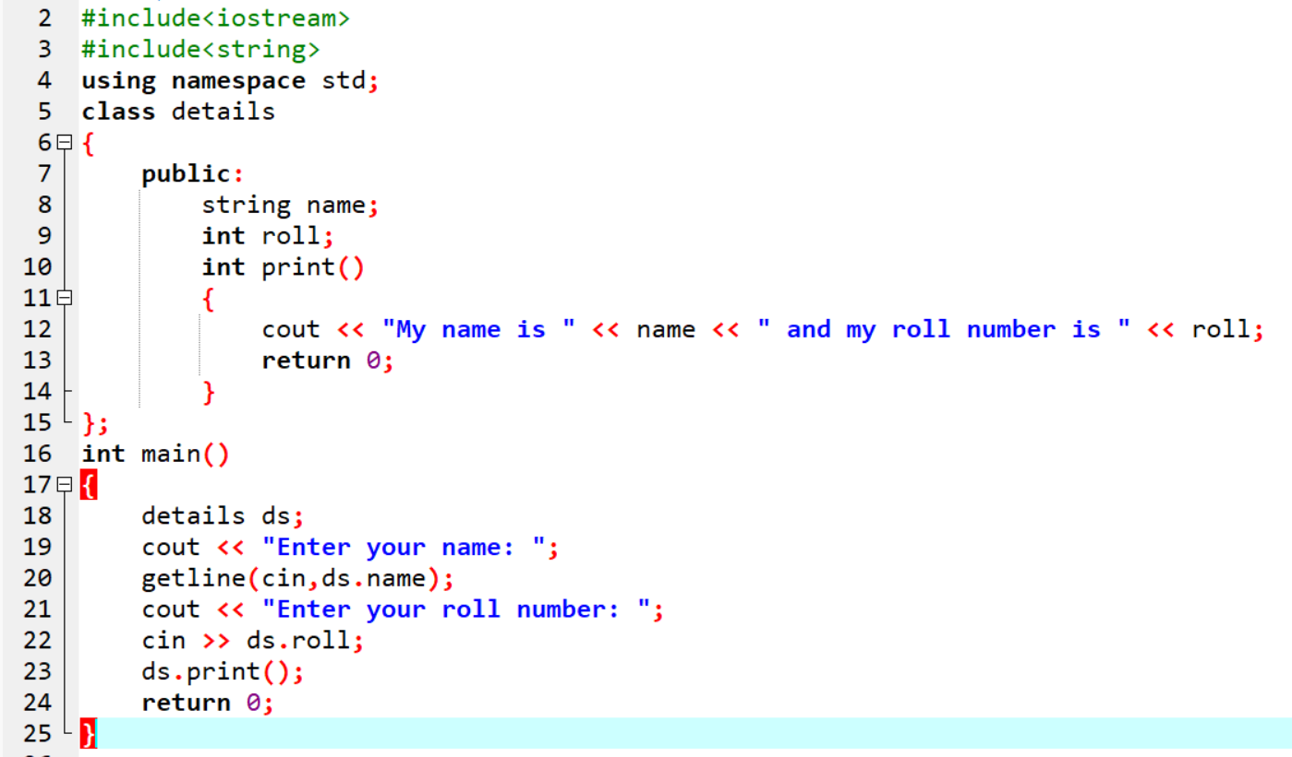
Output:-
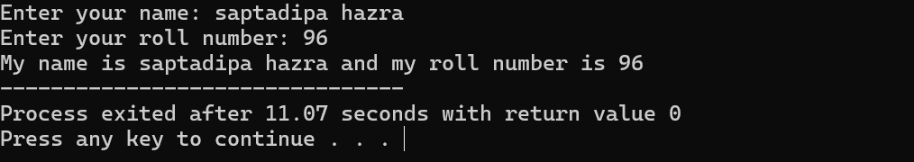

Exp18:-
Title of the program:-
Write a program to print a string from upper case to lower case & vice versa.
Program instruction:-

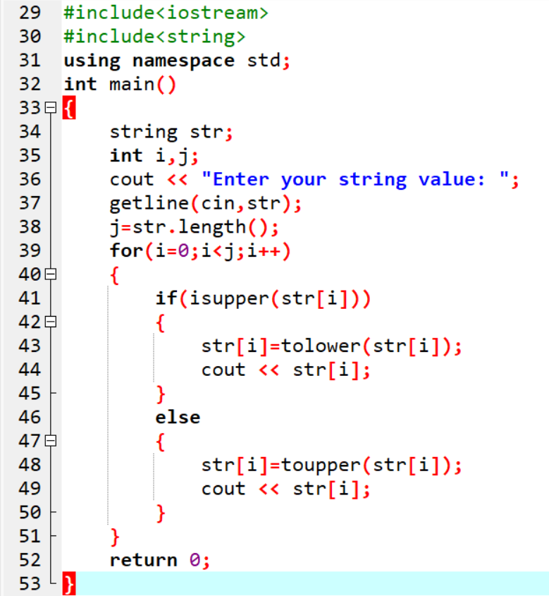

Output:-

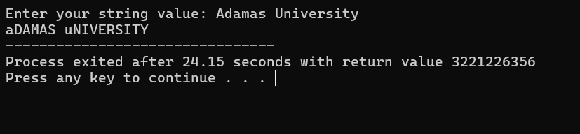
Exp19:-
Title of the program:-
Write a program to extract integer characters from a string. If no integer found then print “no integer”.
Program instruction:-

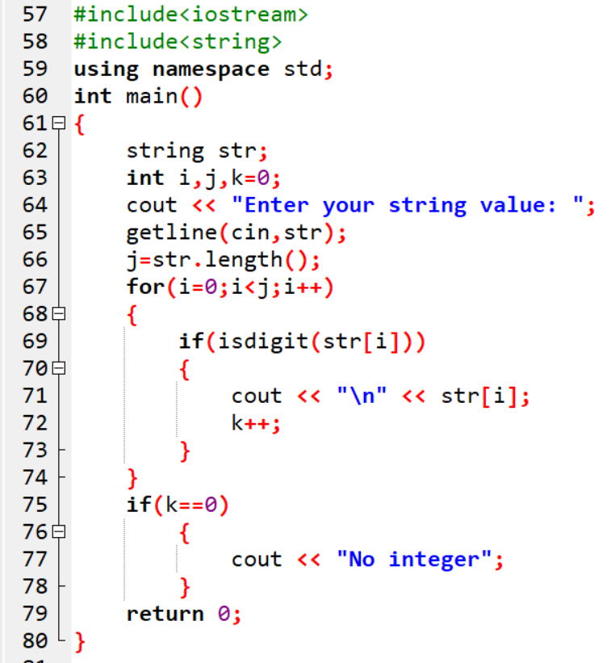

Output:-

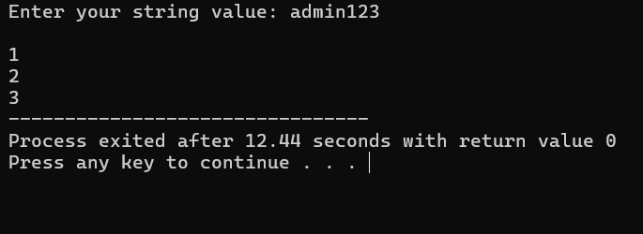
Exp20:-
Title of the program:-
Username= “admin123” & password= “sysadmin@1234”. Compare the credentials with user inputs. If correct credentials are given by user then print “logged in” else print “try again”.
Program instruction:-

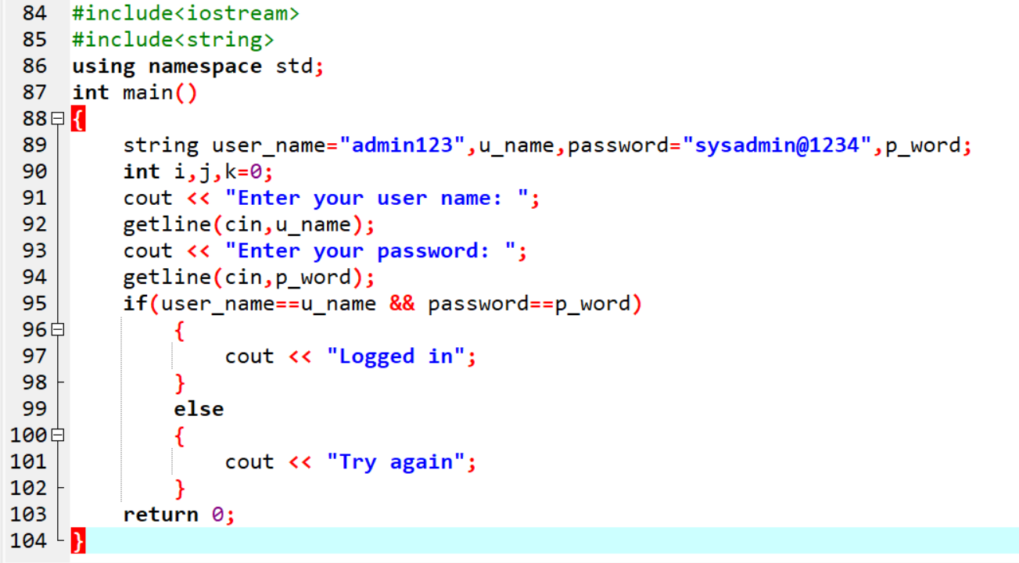

Output:-

